Tenda A18 - How to modify WiFi name&password and hide wireless signal
Note: This document applies to A18 users who want to modify WiFi name&password or want to hide wireless signal after first setting.

There three steps(both mobile & computer) to complete the setting.
Step1: Use your phone or your computer to connect A18’s wireless signal, or use a network cable to connect the A18's LAN port to your computer.
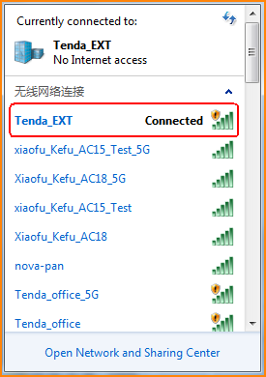

Step2: Input the address re.tenda.cn in the browser.
Open the browser, input re.tenda.cn in the address bar then come into the configuration page. If you have already set the login password on the first setting,just input your login password (Note: If you forget your password,please reset A18 to factory default).
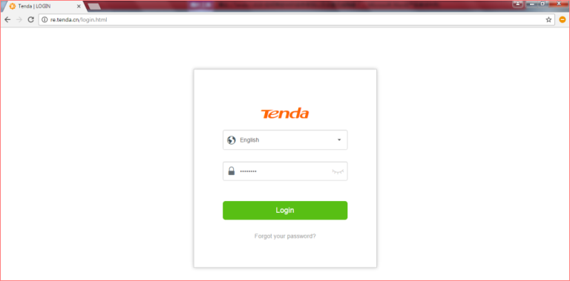

Step3:Modify WiFi name and password(if you want), hide the wireless signal and then reconnect the signal.
Then come into configuration page, click WiFi Settings,you can modify 2.4G and 5G signal’s name&password, check the Hide checkbox next to SSID and then the extended signal can be hidden.(Note: After signal is hidden,all terminal devices can no longer find it.You should add the WiFi signal manually if you want connect it.So you should set the WiFi’s name as simple as possible if you want to hide it.)
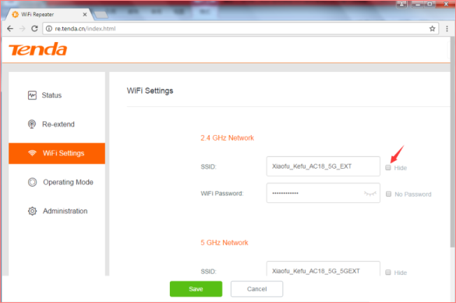

Please refer to other setup documents of product if you want to set other parameters.

